The JoHari Window: identifying learning needs
The JoHari window is so important that I refer to it time and time again as an educator (even though I’ve been doing the job for a number of years). Take a look at the model below but don’t worry if it all looks a bit confusing. Just glance at it for now and then we’ll go through it step by step until you get a firm grasp of it.
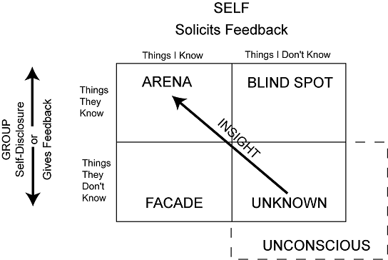
The JoHari window basically helps you identify what the learner does and in so doing helps you determine the learner’s needs and thus set aims and objectives for future educational sessions.
Let’s look at how the window works with the trainer-trainee model so you understand it better. In the model above, consider ‘self’ as the trainee and ‘group’ as the trainer.
The arena – this is where there are things the trainee knows they are bad at and others like the trainer also knows they are bad at. For instance, one trainee might be really bad at family planning and the trainee knows it (because they did not do an O&G job and they know they find this area pretty difficult). The trainer also knows it perhaps because other doctors in the practice may have mentioned something or the trainer may have seen patients previously seen by the trainee with family planning issues which were not managed very well. The point is this: learning needs in the arena box are relatively easy to identify: both the trainee and the trainer know the trainee is bad at xxxx and that it needs to be tackled. It’s in the arena box (where both trainer and trainee are aware of learning needs) that you want to end up in if you’re in any of the other boxes.
The facade – this is where the trainee knows their bad at something but the trainer doesn’t. For instance, a trainee might know within themselves (through dealing with patients) that they’re pretty rubbish at dealing with the menopause and HRT. The trainer might not know this because there has been no reason to be concerned – no one’s complained etc.
How to move to the arena: In this situation, it’s important to create an honest, open and safe educational environment so that the trainee can share these needs with you. In that way, you’ll get the trainee to reveal learning needs that are ‘real’ and needed. At the end, instead of just the trainee knowing about this learning need, both you and the trainee will know: hence you’ve moved to the arena box.
The blind spot – this is where the trainee doesn’t realise their rubbish at something but the trainer does. So, a trainee might have done a quick ‘read up’ on say depression and doesn’t feel to have any difficulty with handling and managing depressed patients. But the trainer might have been told by other docs or may have seen these patients him/herself and realised that there is more that should have been done.
How to move to the arena: Again, if you create an honest, open and safe educational environment you should be able to feed this back to the trainee without any confrontation so you can then both decide on how to tackle this newly found aim/objective.
The unknown – this is the most difficult bit to tackle and explain. This is where the trainee doesn’t realise they’re not particularly good at something and you as the trainer doesn’t know either.
How to move to the arena: Okay, so I hear you ask ‘how on Earth do we figure out their learning needs if no-one knows?’. Throughout training you will both have flashes of insight into some learning needs not previously known. As facilitators, you might achieve this through helping the learner to question their ideas by challenging them, reflecting, giving feedback, etc. This helps them to become aware of areas or gaps of ignorance, and stimulates them to develop new understandings. Alternatively it might be through various tools (like random case analyses, significant event analyses and complaints). Once ‘discovered’, they then become part of the ‘arena’ (i.e. you both now know what the trainee doesn’t know) and you can then start to tackle them.

The overall idea behind JoHari’s window is to make the unknown box smaller and smaller and thus the arena bigger and bigger throughout the training period.

Remember what I said earlier: It doesn’t matter which box you and your trainee start off in, you want to end up in the arena box: which is the box where learning needs are laid out on the table and visible to both trainer and trainee (enabling you both to then identify ways of tackling them).

P.S. It’s called the JoHari window because it was developed by someone called Jo and his colleague Harry.

